Training Institute

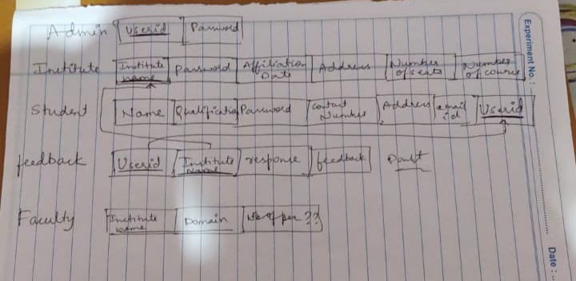

There is a single login page for everyone to access their details, based on id and password we are going to validate it and allow that role to have their access.

We have to ask the user to enter his role : (maybe use switch case)
1.Admin
2.Institute
3.Student

After he chooses we have to display his operations in another switch:
Like special privileges for certain roles..

The diagram talks about admin having user id and password which is apt because he/she needs to have specific accesses. We'll assign admin with set userid and password because registration is not required for admin.

Institute and Student have a registration process and we have to work on the id part which we’ll use to link tables to each other (foreign keys).

Feedback is universal and it’s best if it is anonymous so we’ll drop the userid and use it for feedback which can’t be deleted or modified once entered.

Faculty table is required for students to upload and admin and institute to view.

With this we have to perform CRUD operations on the database stored on localhost:3306.

Tables Required

Institute

Insid int primary key
Insname varchar (30) unique not null
Passwd varchar(15) unique not null
Affdate date not null
Addr varchar (100) not null
Seats int not null

Student

Userid varchar(20) primary key
Emailid varchar(20) unique not null
Name varchar(40) not null
Qualification varchar (20) not null
Passwd varchar(15) unique not null
Number varchar(13) not null
Addr varchar(100) not null

Admin

Adminid varchar(20) primary key
Passwd varchar(15) unique not null

Feedback

Feedbackid int primary key auto increment
Insid fk
Userid fk
Desc varchar(200)
Feedbackdate date

Faculty

Facultyid int primary key auto increment
Name varchar(20) not null
Insid fk (one to may)

Course

Courseid int primary key auto increment
Name varchar(20) unique not null
Insid fk (one to many)
AdmissionRequest
(req and res)

Reqid int primary key auto increment
Userid fk
Courseid fk
Reqdate date
Status Boolean

Associate student with institute pk-fk relationship.Insid in student table.

AdminDAO
Four actions: view ins, del ins, view student, view feedback

InstituteDAO:
Actions:
View and update stu details
View req (student sends req for getting admit)
Update ins prof
Send response(accept or reject)
Viewfeedback
Adding a course

StudentDAO:
Update prof
Send req to college
View res
Send feedback
.
.

POJO boolean type should be Wrapper Boolean

Seven pojo class(sep package)
Seven dao class(sep package)
Each action separate method
Proper package and class names
Use logback custom exceptions in a file and call respective ones
(Institute method will call faculty method
Faculty will call institute
Dao created when institute creates entries)
String datamember for date (parse into date)
Converting string type into date type in mysql jdbc

Enhancement for final case study:
Many-to-many between course and institute.
Many-to-many between student and admissionRequest
History for institute

